DATA SCIENCE

PRACTICAL RECORD BOOK

B. E. SEVENTH SEMESTER

NAME: _______________________________

ROLL NO: ________ BATCH: _____________

BRANCH: _____________SECTION: _________

COLLEGE ENROLMENT NO: _________________

UNIVERSITY ENROLMENT NO: ________________

CERTIFICATE

This is to certify that this is the bonafide record of the practical work done by Mr./ Miss. _______________________________ bearing Roll No.________of B. E. Sixth Semester section ______ of________ Branch in Engineering Digital Signal Processing Practical during the academic session __________. His /Her work has been satisfactory and he/she is awarded ____ grade considering his/her performance during the practical sessions.

College Enrolment No. _______________
University Enrolment No. ______________
Hall Ticket No. ______________
Date: ______________

Signature and stamp of Signature of
Head of Department Subject Teacher

I N D E X
Sr. No | Name of Experiment | Date of Performance | Date of Submission | Marks/ Grade | Signature | Remark
1 | Write a R program to Create a list containing Strings, numbers, vectors and Logical Values.
2 | Write a R program to merge two given lists into one list.
3 | Write a R program to create a list containing a vector, a matrix and a list an give names to the Elements in the list. Access the first and second element of the list
4 | Write a R Program to Read the data from same and different Directory
5 | Write a program to Read and load data from large datasets
6. | Install the necessary R packages and apply data manipulation packages –dplyr,data .table,reshape2,tidyr,lubricate
7. | Write a R program to implement Decision tree
8. | Write a R program to K-Nearest Neighbour Algorithm
9. | Create a linear regression model using housing dataset IN JUPYTER.
10. | Create a Logistic regression model using housing dataset IN JUPYTER.

LABORTATORY INSTRUCTIONS FOR STUDENTS

Before commencing practical work, the students are advised to bear in mind the following points:-

- Strict silence must be observed during laboratory practical.
- Students should not enter or leave the laboratory without permission of the teacher.
- Handle the apparatus very carefully. During performance of practical the computer allotted to students should be handled properly without applying force.
- In case of breakage/damage of the issued computer, the concerned students will have to pay the requisite fine.
- Evaluate and run the programs and get it checked by the respective teacher and thereafter shut down the supply of respective computer while the student has evaluated and shown the result to respective teacher.
- Record the result of all your experiments in the ‘laboratory journal’ in the prescribed form & get it duly signed by the concerned teacher on the day of performance of the experiment.
- Disconnect the connections & return only the issued apparatus before leaving the laboratory.
- Fill in the index page after completing each experiment.
- Do each experiment will full understanding prepare viva-voce thoroughly for each experiment.
During the practical session in the laboratory, students must take care of their belongings viz. calculator, journal, money purse etc.

Date: _________________
EXPERIMENT NO: 1

AIM: Write a R program to Create a list containing Strings, numbers, vectors and Logical Values.

SOFTWARE USED: R Language using R studio in Juypter Notebook

THEORY:

R is a free, open source statistical programming language. It is useful for data cleaning, analysis, and visualization. R is an interpreted language, not a compiled one. This means that you type something into R and it does what you tell it. It is both a command line software and a programming environment. It is an extensible, open-source language and computing environment for Windows, Macintosh, UNIX, and Linux platforms, which allows for the user to freely distribute, study, change, and improve the software. It is basically a free, super big, and complex calculator. You will be using R to accomplish all data analysis tasks in this class. You might be wondering “Why in the world do we need to know how to use a statistical software program?” Here are the main reasons:

You will be learning about abstract concepts in lecture and the readings. Applying these concepts using real data is an important form of learning. A statistical software program is the most efficient (and in many cases the only) means of running data analyses, not just in the cloistered setting of a university classroom, but especially in the real world. Applied data analysis will be the way we bridge statistical theory to the “real world.” And R is the vehicle for accomplishing this.

In order to do applied data analysis outside of the classroom, you need to know how to use a statistical program. There is no way around it as we don’t live in an exclusively pen and paper world. If you want to collect data on soil health, you need a program to store and analyze that data. If you want to collect data on the characteristics of recent migrants, you need a program to store and analyze that data.

- It is free. Most programs are not;
- It is open source. Which means the software is community supported. This allows you to get help not from some big corporation (e.g. Microsoft with Excel), but people all around the world who are using R. And R has a lot of users, which means that if you have a problem, and you pose it to the user community, someone will help you;
- It is powerful and extensible (meaning that procedures for analyzing data that don’t currently exist can be readily developed);
- It has the capability for mapping data, an asset not generally available in other statistical software;
- If it isn’t already there, R is becoming the de-facto data analysis tool in the social sciences.

Code:

list_data = list("Python", "PHP", c(5, 7, 9, 11), TRUE, 125.17, 75.83)
print("Data of the list:")
print(list_data)

Output:
[1] "Data of the list:"
[[1]]
[1] "Python"

[[2]]
[1] "PHP"

[[3]]
[1] 5 7 9 11

[[4]]
[1] TRUE

[[5]]
[1] 125.17

[[6]]
[1] 75.83

RESULT: Thus we have studied how to Create a list containing Strings, numbers, vectors and Logical Values.

Viva Voce Answers:

1.

2.

Marks: ________/10 Signature_______________

Viva Voce Question Bank
- What is R Language?
- What are the various function of R Language?
- Name five different properties of R Language?

Date: ________________
Experiment No: 02

AIM: Write a R program to merge two given lists into one list.

SOFTWARE USED: R Language using R studio in Juypter Notebook

THEORY:

R is a language and environment for statistical computing and graphics. It is a GNU project which is similar to the S language and environment which was developed at Bell Laboratories (formerly AT&T, now Lucent Technologies) by John Chambers and colleagues. R can be considered as a different implementation of S. There are some important differences, but much code written for S runs unaltered under R.
R provides a wide variety of statistical (linear and nonlinear modeling, classical statistical tests, time-series analysis, classification, clustering) and graphical techniques, and is highly extensible. The S language is often the vehicle of choice for research in statistical methodology, and R provides an Open Source route to participation in that activity

The R environment

R is an integrated suite of software facilities for data manipulation, calculation and graphical display. It includes
- an effective data handling and storage facility,
- a suite of operators for calculations on arrays, in particular matrices,
- a large, coherent, integrated collection of intermediate tools for data analysis,
- graphical facilities for data analysis and display either on-screen or on hardcopy, and
- a well-developed, simple and effective programming language which includes conditionals, loops, user-defined recursive functions and input and output facilities.
The term “environment” is intended to characterize it as a fully planned and coherent system, rather than an incremental accretion of very specific and inflexible tools, as is frequently the case with other data analysis software.
R, like S, is designed around a true computer language, and it allows users to add additional functionality by defining new functions. Much of the system is itself written in the R dialect of S, which makes it easy for users to follow the algorithmic choices made. For computationally-intensive tasks, C, C++ and Fortran code can be linked and called at run time. Advanced users can write C code to manipulate R objects directly.
Many users think of R as a statistics system. We prefer to think of it as an environment within which statistical techniques are implemented. R can be extended (easily) via packages. There are about eight packages supplied with the R distribution and many more are available through the CRAN family of Internet sites covering a very wide range of modern statistics.
Code:
n1 = list(1,2,3)
c1 = list("Red", "Green", "Black")
print("Original lists:")
print(n1)
print(c1)
print("Merge the said lists:")
mlist = c(n1, c1)
print("New merged list:")
print(mlist)

Output Here:

[1] "Original lists:"
[[1]]
[1] 1

[[2]]
[1] 2

[[3]]
[1] 3

[[1]]
[1] "Red"

[[2]]
[1] "Green"

[[3]]
[1] "Black"

[1] "Merge the said lists:"
[1] "New merged list:"
[[1]]
[1] 1

[[2]]
[1] 2

[[3]]
[1] 3

[[4]]
[1] "Red"

[[5]]
[1] "Green"

[[6]]
[1] "Black"

RESULT:
Hence, we have studied to merge two given lists into one list

Viva Voce Question & Answer:

1.

2.

Marks: ________/10 Signature_______________
Viva Questions:
1. Differentiate between Scalars, vector, list, Matrix and Data frame..
2. Differentiate between R and Python in terms of functionality.
3 What are the applications of R?.
4. How to get the name of the current working directory in R?.

Date: ________________
Experiment No: 3

AIM: Write a R program to create a list containing a vector, a matrix and a list an give names to the Elements in the list. Access the first and second element of the list.

SOFTWARE USED: R Language using R studio in Juypter Notebook

THEORY:
A list in R is a generic object consisting of an ordered collection of objects. Lists are one-dimensional, heterogeneous data structures. The list can be a list of vectors, a list of matrices, a list of characters and a list of functions, and so on. A list is a vector but with heterogeneous data elements. A list in R is created with the use of list () function. R allows accessing elements of an R list with the use of the index value. In R, the indexing of a list starts with 1 instead of 0 like in other programming languages

INPUT:
list_data <- list(c("Red","Green","Black"), matrix(c(1,3,5,7,9,11), nrow = 2),
list("Python", "PHP", "Java"))
print("List:")
print(list_data)
names(list_data) = c("Color", "Odd numbers", "Language(s)")
print("List with column names:")
print(list_data)
print('1st element:')
print(list_data[1])
print('2nd element:')
print(list_data[2])

Output Here:
[1] "List:"
[[1]]
[1] "Red" "Green" "Black"

[[2]]
[,1] [,2] [,3]
[1,] 1 5 9
[2,] 3 7 11

[[3]]
[[3]][[1]]
[1] "Python"

[[3]][[2]]
[1] "PHP"

[[3]][[3]]
[1] "Java"

[1] "List with column names:"
$Color
[1] "Red" "Green" "Black"

$`Odd numbers`
[,1] [,2] [,3]
[1,] 1 5 9
[2,] 3 7 11

$`Language(s)`
$`Language(s)`[[1]]
[1] "Python"

$`Language(s)`[[2]]
[1] "PHP"

$`Language(s)`[[3]]
[1] "Java"

[1] "1st element:"
$Color
[1] "Red" "Green" "Black"

[1] "2nd element:"
$`Odd numbers`
[,1] [,2] [,3]
[1,] 1 5 9
[2,] 3 7 11

RESULT: Hence, we have create a list containing a vector, a matrix and a list an giveN names to the Elements in the list Successfully
Viva Voce Question and Answers:

1.

2.

Marks: ________/10 Signature_______________

Viva Questions:

- Define Martix Creation In R language.
- Advantages of R Language.

Date: ________________
Experiment No: 4

AIM:
Write a R Program to Read the data from same and different Directory
.

SOFTWARE USED: R Language using R studio in Juypter Notebook

THEORY:
When a program is terminated, the entire data is lost. Storing in a file will preserve our data even if the program terminates. If we have to enter a large number of data, it will take a lot of time to enter them all. However, if we have a file containing all the data, we can easily access the contents of the file using a few commands in R. You can easily move your data from one computer to another without any changes. So those files can be stored in various formats. It may be stored in a i.e..txt(tab-separated value) file, or in a tabular format i.e .csv(comma-separated value) file or it may be on the internet or cloud. R provides very easier methods to read those files.

File reading in R
One of the important formats to store a file is in a text file. R provides various methods that one can read data from a text file.

read.delim(): This method is used for reading “tab-separated value” files (“.txt”). By default, point (“.”) is used as decimal point.
Syntax: read.delim(file, header = TRUE, sep = “\t”, dec = “.”, …)
Parameters:
• file: the path to the file containing the data to be read into R.
• header: a logical value. If TRUE, read.delim() assumes that your file has a header row, so row 1 is the name of each column. If that’s not the case, you can add the argument header = FALSE.
• sep: the field separator character. “\t” is used for a tab-delimited file.
• dec: the character used in the file for decimal points.

INPUT:
# R program reading a text file

# Read a text file using read.delim()
myData = read.delim("KDKCE.txt", header = FALSE)
print(myData)

Output Here:
A computer science portal for ETC.

RESULT: Hence, we have Read the data from text file in R Language Successfully

Viva Voce Question and Answers:

- In R how you can import Data?.
- How can you save your data in R?

Marks: ________/10 Signature_______________

Date: ________________
Experiment No: 5

AIM: Write a program to Read and load data from large datasets.

SOFTWARE USED: R Language using R studio in Juypter Notebook

THEORY:
There are a few very useful functions for reading data into R.
- read.table() and read.csv() are two popular functions used for reading tabular data into R.
- readLines() is used for reading lines from a text file.
- source() is a very useful function for reading in R code files from a another R program.
- dget() function is also used for reading in R code files.
- load() function is used for reading in saved workspaces
- unserialize() function is used for reading single R objects in binary format.

Functions for Writing Data to Files:
There are similar functions for writing data to files
- write.table() is used for writing tabular data to text files (i.e. CSV).
- writeLines() function is useful for writing character data line-by-line to a file or connection.
- dump() is a function for dumping a textual representation of multiple R objects.
- dput() function is used for outputting a textual representation of an R object.
- save() is useful for saving an arbitrary number of R objects in binary format to a file.
- serialize() is used for converting an R object into a binary format for outputting to a connection (or
file).

Reading Data Files with read.table():
The read.table() function is one of the most commonly used functions for reading data in R. TO get the help file for read.table() just type ?read.table in R console.
The read.table() function has a few important arguments:
- file, the name of a file, or a connection
- header, logical indicating if the file has a header line
- sep, a string indicating how the columns are separated
- colClasses, a character vector indicating the class of each column in the dataset
- nrows, the number of rows in the dataset. By default read.table() reads an entire file.
- comment.char, a character string indicating the comment character. This defalts to “#”. If there are no commented lines in your file, it’s worth setting this to be the empty string “”.
- skip, the number of lines to skip from the beginning
- stringsAsFactors, should character variables be coded as factors? This defaults to TRUE because back in the old days, if you had data that were stored as strings, it was because those strings represented levels of a categorical variable. Now we have lots of data that is text data and they don’t always represent categorical variables. So you may want to set this to be FALSE in those cases. If you always want this to be FALSE, you can set a global option via options(stringsAsFactors = FALSE). I’ve never seen so much heat generated on discussion forums about an R function argument than the stringsAsFactors argument.

INPUT:
# R program to read one line at a time

# Import the readr library
library(readr)

# read_lines() to read one line at a time
myData = read_lines("geeksforgeeks.txt", n_max = 1)
print(myData)

# read_lines() to read two line at a time
myData = read_lines("geeksforgeeks.txt", n_max = 2)
print(myData)
Output Here:
A computer science portal for ETC.
ETC Department of k.d.k.c.e

RESULT: Hence, we have Read and load data from large datasets in R Language Successfully

Viva Voce Question and Answers:

- Explain how data is aggregated in R?
- Explain what is With () and By () function in R is used for?

Marks: ________/10 Signature_______________

Date: ________________
Experiment No: 6

AIM: Install the necessary R packages and apply data manipulation packages –Dplyr, data .table, reshape2, tidyr, lubricate.

SOFTWARE USED: R Language using R studio in Juypter Notebook

THEORY:
In order to manipulate the data, R provides a library called dplyr which consists of many built-in methods to manipulate the data. So to use the data manipulation function, first need to import the dplyr package using library(dplyr) line of code. Below is the list of a few data manipulation functions present in dplyr package.
Function Name | Description
filter() | Produces a subset of a Data Frame.
distinct() | Removes duplicate rows in a Data Frame
arrange() | Reorder the rows of a Data Frame
select() | Produces data in required columns of a Data Frame
rename() | Renames the variable names
mutate() | Creates new variables without dropping old ones.
transmute() | Creates new variables by dropping the old.
summarize() | Gives summarized data like Average, Sum, etc.
filter() method
The filter() function is used to produce the subset of the data that satisfies the condition specified in the filter() method. In the condition, we can use conditional operators, logical operators, NA values, range operators etc. to filter out data. Syntax of filter() function is given below-
filter(dataframeName, condition)
In the below code we used filter() function to fetch the data of players who scored more than 100 runs from the “stats” data frame.
Input
# import dplyr package
library(dplyr)
# create a data frame
stats <- data.frame(player=c('A', 'B', 'C', 'D'),
runs=c(100, 200, 408, 19),
wickets=c(17, 20, NA, 5))
# fetch players who scored more
# than 100 runs
filter(stats, runs>100)

Output
player runs wickets
1 B 200 20
2 C 408 NA
Here in this example, we used distinct() method to remove the duplicate rows from the data frame and also remove duplicates based on a specified column.
Input

# import dplyr package

library(dplyr)

# create a data frame

stats <- data.frame(player=c('A', 'B', 'C', 'D', 'A', 'A'),

runs=c(100, 200, 408, 19, 56, 100),

wickets=c(17, 20, NA, 5, 2, 17))

# removes duplicate rows

distinct(stats)

#remove duplicates based on a column

distinct(stats, player, .keep_all = TRUE)
Output Here:
player runs wickets
1 A 100 17
2 B 200 20
3 C 408 NA
4 D 19 5
5 A 56 2
player runs wickets
1 A 100 17
2 B 200 20
3 C 408 NA
4 D 19 5

RESULT: Hence, we have necessary R packages and apply data manipulation packages –Dplyr, data .table, reshape2, tidyr, lubricate

Viva Voce Question and Answers:

1. Write about all summary commands in R
2. How to plot multiple curves in same graph? Explain with example?

Marks: ________/10 Signature_______________

Date: ________________
Experiment No: 7

AIM: Write a R program to implement Decision tree Algorithm.

SOFTWARE USED: R Language using R studio in Juypter Notebook

THEORY:
Decision Trees are useful supervised Machine learning algorithms that have the ability to perform both regression and classification tasks. It is characterized by nodes and branches, where the tests on each attribute are represented at the nodes, the outcome of this procedure is represented at the branches and the class labels are represented at the leaf nodes. Hence it uses a tree-like model based on various decisions that are used to compute their probable outcomes. These types of tree-based algorithms are one of the most widely used algorithms due to the fact that these algorithms are easy to interpret and use. Apart from this, the predictive models developed by this algorithm are found to have good stability and a descent accuracy due to which they are very popular
Types of Decision Trees
Decision stump: Used for generating a decision tree with just a single split hence also known as a one-level decision tree. It is known for its low predictive performance in most cases due to its simplicity.
M5: Known for its precise classification accuracy and its ability to work well to a boosted decision tree and small datasets with too much noise.
ID3(Iterative Dichotomiser 3): One of the core and widely used decision tree algorithms uses a top-down, greedy search approach through the given dataset and selects the best attribute for classifying the given dataset
C4.5: Also known as the statistical classifier this type of decision tree is derived from its parent ID3. This generates decisions based on a bunch of predictors.
C5.0: Being the successor of the C4.5 it broadly has two models namely the basic tree and rule-based model, and its nodes can only predict categorical targets.
CHAID: Expanded as Chi-squared Automatic Interaction Detector, this algorithm basically studies the merging variables to justify the outcome on the dependent variable by structuring a predictive model
MARS: Expanded as multivariate adaptive regression splines, this algorithm creates a series of piecewise linear models which is used to model irregularities and interactions among variables, they are known for their ability to handle numerical data with greater efficiency.
Conditional Inference Trees: This is a type of decision tree that uses a conditional inference framework to recursively segregate the response variables, it’s known for its flexibility and strong foundations.
CART: Expanded as Classification and Regression Trees, the values of the target variables are predicted if they are continuous else the necessary classes are identified if they are categorical.
As it can be seen that there are many types of decision trees but they fall under two main categories based on the kind of target variable, they are:
Categorical Variable Decision Tree: This refers to the decision trees whose target variables have limited value and belong to a particular group.
Continuous Variable Decision Tree: This refers to the decision trees whose target variables can take values from a wide range of data types.
Decision Tree in R Programming Language
Let us consider the scenario where a medical company wants to predict whether a person will die if he is exposed to the Virus. The important factor determining this outcome is the strength of his immune system, but the company doesn’t have this info. Since this is an important variable, a decision tree can be constructed to predict the immune strength based on factors like the sleep cycles, cortisol levels, supplement intaken, nutrients derived from food intake, and so one of the person which is all continuous variables.
Working of a Decision Tree in R
Partitioning: It refers to the process of splitting the data set into subsets. The decision of making strategic splits greatly affects the accuracy of the tree. Many algorithms are used by the tree to split a node into sub-nodes which results in an overall increase in the clarity of the node with respect to the target variable. Various Algorithms like the chi-square and Gini index are used for this purpose and the algorithm with the best efficiency is chosen.
Pruning: This refers to the process wherein the branch nodes are turned into leaf nodes which results in the shortening of the branches of the tree. The essence behind this idea is that overfitting is avoided by simpler trees as most complex classification trees may fit the training data well but do an underwhelming job in classifying new values.
Selection of the tree: The main goal of this process is to select the smallest tree that fits the data due to the reasons discussed in the pruning section.
Important factors to consider while selecting the tree in R
Entropy:
Mainly used to determine the uniformity in the given sample. If the sample is completely uniform then entropy is 0, if it’s uniformly partitioned it is one. The higher the entropy more difficult it becomes to draw conclusions from that information.
Information Gain:
Statistical property which measures how well training examples are separated based on the target classification. The main idea behind constructing a decision tree is to find an attribute that returns the smallest entropy and the highest information gain. It is basically a measure in the decrease of the total entropy, and it is calculated by computing the total difference between the entropy before split and average entropy after the split of dataset based on the given attribute values.
Input
Installing the required libraries
install.packages('datasets')
install.packages('caTools')
install.packages('party')
install.packages('dplyr')
install.packages('magrittr')
Import required libraries and Load the dataset readingSkills and execute head(readingSkills)

library(datasets)
library(caTools)
library(party)
library(dplyr)
library(magrittr)

data("readingSkills")
head(readingSkills)

Output
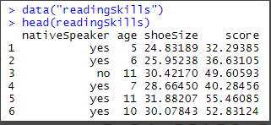

RESULT: Hence, we have necessary R packages and have Implememnted Decision Tree

Marks: ________/10 Signature_______________

Date: ________________
Experiment No: 8

AIM: Write a R program to K-Nearest Neighbour Algorithm.

SOFTWARE USED: R Language using R studio in Juypter Notebook

THEORY:
K-Nearest Neighbor or K-NN is a Supervised Non-linear classification algorithm. K-NN is a Non-parametric algorithm i.e it doesn’t make any assumption about underlying data or its distribution. It is one of the simplest and widely used algorithm which depends on it’s k value(Neighbors) and finds it’s applications in many industries like finance industry, healthcare industry etc.
Types of Decision Trees
In the KNN algorithm, K specifies the number of neighbors and its algorithm is as follows:
Choose the number K of neighbor.
Take the K Nearest Neighbor of unknown data point according to distance.
Among the K-neighbors, Count the number of data points in each category.
Assign the new data point to a category, where you counted the most neighbors.
For the Nearest Neighbor classifier, the distance between two points is expressed in the form of Euclidean Distance.
Example:
Consider a dataset containing two features Red and Blue and we classify them. Here K is 5 i.e we are considering 5 neighbors according to Euclidean distance
The Dataset
Iris dataset consists of 50 samples from each of 3 species of Iris(Iris setosa, Iris virginica, Iris versicolor) and a multivariate dataset introduced by British statistician and biologist Ronald Fisher in his 1936 paper The use of multiple measurements in taxonomic problems. Four features were measured from each sample i.e length and width of the sepals and petals and based on the combination of these four features, Fisher developed a linear discriminant model to distinguish the species from each other.

Input

# Loading data

data(iris)

# Structure

str(iris)

Performing K Nearest Neighbor on Dataset

Using the K-Nearest Neighbor algorithm on the dataset which includes 11 persons and 6 variables or attributes

# Installing Packages

install.packages("e1071")

install.packages("caTools")

install.packages("class")

# Loading package

library(e1071)

library(caTools)

library(class)

# Loading data

data(iris)

head(iris)

# Splitting data into train

# and test data

split <- sample.split(iris, SplitRatio = 0.7)

train_cl <- subset(iris, split == "TRUE")

test_cl <- subset(iris, split == "FALSE")

# Feature Scaling

train_scale <- scale(train_cl[, 1:4])

test_scale <- scale(test_cl[, 1:4])

# Fitting KNN Model

# to training dataset

classifier_knn <- knn(train = train_scale,

test = test_scale,

cl = train_cl$Species,

k = 1)

classifier_knn

# Confusiin Matrix

cm <- table(test_cl$Species, classifier_knn)

cm

# Model Evaluation - Choosing K

# Calculate out of Sample error

misClassError <- mean(classifier_knn != test_cl$Species)

print(paste('Accuracy =', 1-misClassError))

# K = 3

classifier_knn <- knn(train = train_scale,

test = test_scale,

cl = train_cl$Species,

k = 3)

misClassError <- mean(classifier_knn != test_cl$Species)

print(paste('Accuracy =', 1-misClassError))

# K = 5

classifier_knn <- knn(train = train_scale,

test = test_scale,

cl = train_cl$Species,

k = 5)

misClassError <- mean(classifier_knn != test_cl$Species)

print(paste('Accuracy =', 1-misClassError))

# K = 7

classifier_knn <- knn(train = train_scale,

test = test_scale,

cl = train_cl$Species,

k = 7)

misClassError <- mean(classifier_knn != test_cl$Species)

print(paste('Accuracy =', 1-misClassError))

# K = 15

classifier_knn <- knn(train = train_scale,

test = test_scale,

cl = train_cl$Species,

k = 15)

misClassError <- mean(classifier_knn != test_cl$Species)

print(paste('Accuracy =', 1-misClassError))

# K = 19

classifier_knn <- knn(train = train_scale,

test = test_scale,

cl = train_cl$Species,

k = 19)

misClassError <- mean(classifier_knn != test_cl$Species)

print(paste('Accuracy =', 1-misClassError))

Output
Model classifier_knn(k=1):

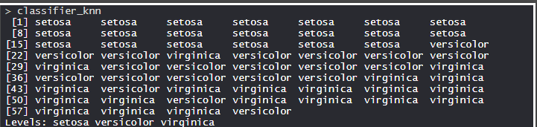

The KNN model is fitted with a train, test, and k value. Also, the Classifier Species feature is fitted in the model.

Confusion Matrix:

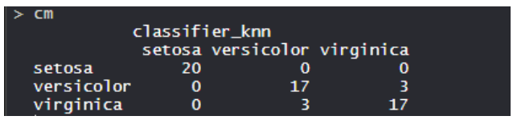

RESULT: Hence, we have necessary R packages and have Implemented K nearest Neighbour Algorithm

Marks: ________/10 Signature_______________

Date: ________________
Experiment No: 9

AIM: Create a linear regression model using housing dataset IN JUPYTER.

SOFTWARE USED:Ananconda software Juypter Notebook

THEORY:
Linear regression is a model that predicts a relationship of direct proportionality between the dependent variable (plotted on the vertical or Y axis) and the predictor variables (plotted on the X axis) that produces a straight line, like so:
Boston Housing Data: This dataset was taken from the StatLib library and is maintained by Carnegie Mellon University. This dataset concerns the housing prices in the housing city of Boston. The dataset provided has 506 instances with 13 features.
Input

# Importing Libraries

import numpy as np

import pandas as pd

import matplotlib.pyplot as plt

# Importing Data

from sklearn.datasets import load_boston

boston = load_boston()
boston.data.shape
boston.feature_names

Converting data from nd-array to data frame and adding feature names to the data
data = pd.DataFrame(boston.data)
data.columns = boston.feature_names

data.head(10)

Output
(506,13)

The KNN model is fitted with a train, test, and k value. Also, the Classifier Species feature is fitted in the model.

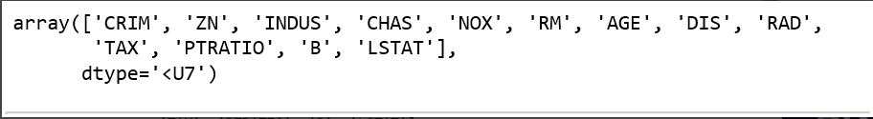

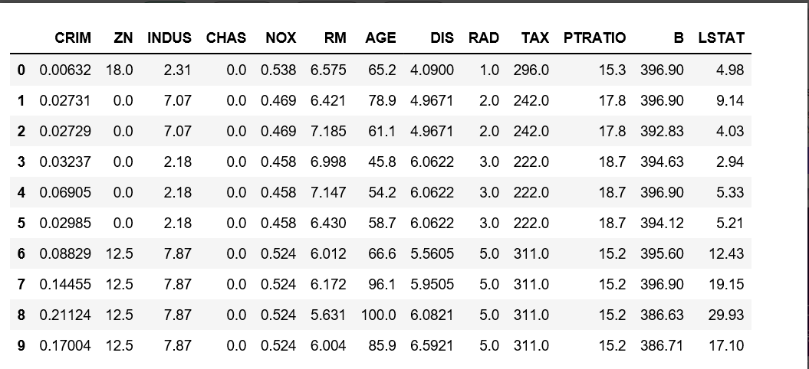

RESULT: Hence, we Have implement Linear Regression using Boston housing Dataset in JUPYTER

Marks: ________/10 Signature_______________

Experiment No: 10

AIM: Create a Logistic regression model using housing dataset IN JUPYTER..

SOFTWARE USED:Ananconda software Juypter Notebook

THEORY:
Logistic Regression is a Machine Learning classification algorithm that is used to predict the probability of a categorical dependent variable. In logistic regression, the dependent variable is a binary variable that contains data coded as 1 (yes, success, etc.) or 0 (no, failure, etc.). In other words, the logistic regression model predicts P(Y=1) as a function of X.
Logistic Regression Assumptions
Binary logistic regression requires the dependent variable to be binary.
For a binary regression, the factor level 1 of the dependent variable should represent the desired outcome.
Only the meaningful variables should be included.
The independent variables should be independent of each other. That is, the model should have little or no multicollinearity.
The independent variables are linearly related to the log odds.
Logistic regression requires quite large sample sizes.
Dataset
The dataset comes from the UCI Machine Learning repository, and it is related to direct marketing campaigns (phone calls) of a Indian banking institution. The classification goal is to predict whether the client will subscribe (1/0) to a term deposit (variable y)
Input
import pandas as pd
import numpy as np
from sklearn import preprocessing
import matplotlib.pyplot as plt
plt.rc("font", size=14)
from sklearn.linear_model import LogisticRegression
from sklearn.model_selection import train_test_split
import seaborn as sns
sns.set(style="white")
sns.set(style="whitegrid", color_codes=True)

Output
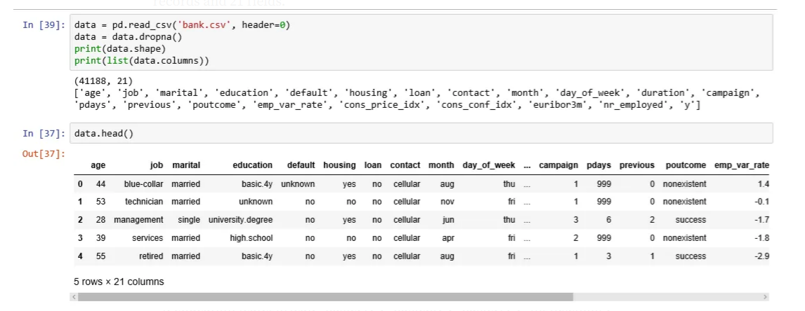

RESULT: Hence, we Have implement Logistic Regression using UCI Dataset in JUPYTER

Marks: ________/10 Signature_______________

